YMCA, Our Lady of Fatima School Age Program

Fire & Evacuation Plan

When Alarm sounds:

Staff A
- Stop all activity in the classroom.
- Have children proceed calmly to the primary exit door or secondary exit if primary exit is not accessible (as diagram below).
- Take a head count to ensure all children are accounted
- Announce loudly for all staff to hear how many children you should have, based on the attendance.
- Take the room attendance clipboard and lead the children outside calmly to the designated meeting place Marshal Park Public School. When the group arrives at the designated meeting place, the fence behind the school, take attendance.

Staff B
- Assist Staff A with ensuring the children proceed to the assigned exit.
- Close all windows.
- Check the room, washroom and cubbies to ensure all children are accounted for in the group.
- Close all doors and walk behind the children to the back fence of the playground.
- As children are proceeding out of the room complete another head count.
- Loudly announce to Staff A the final head count; ensure it is accurate with the attendance
- Walk behind the children to the back fence of the playground.

The Supervisor or designate will complete a full sweep of the Child Care room after everyone has evacuated to ensure there are no children remaining. The Supervisor and/or designate will bring children’s master emergency information to the evacuation site.

Guidelines to ensuring a smooth Evacuation

- Ensure you know how many children you should have at any given time;
- Ensure your attendance is accurate; meaning the children are signed in and out of care when it occurs;
- If a child is visiting another classroom ensure you record on your attendance they are not with you and the room that has the child must record that they are accounted for in that room;
- Ensure your monthly fire/evacuation drills are done at different times of the day each month;
- Ensure the children are not pre-warned about drills
- Stay calm and ensure the children are your first priority.
- Staffs are train on fire extinguisher and evacuation procedures upon employment and review yearly.

Reporting Fire
- Pull fire alarm (located as a star * on the floor plan) At all Exits
- Notify EMERGENCY DEPARTMENT 911

YMCA, Our Lady of Fatima School Age Program

Fire & Evacuation Plan

Primary Exit: Go through door, turn left towards playground, and walk to the back fence.
Secondary Exit is: Go through door, walk to end of hallway, go through the outside doors, and walk towards the back playground fence.

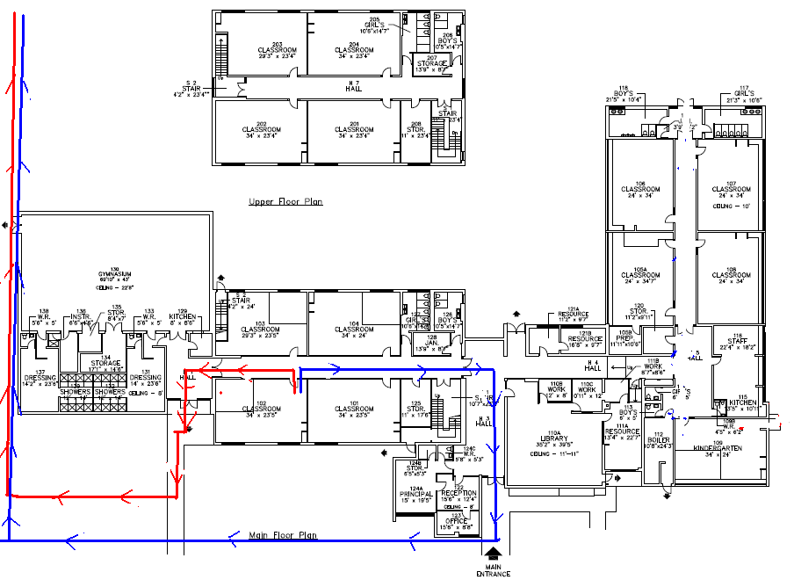
Emergency Evacuation Re-location Site(s)

In the event the Child Care Centre and/or School Age premises are not available for a limited amount of time (example, Fire or the need to evacuate) YMCA staff and children will relocate to John XXIII School. See details below.

Evacuation Site
Site Name | Marshal Park School
Contact | Gisele Lynch, (Principal)
Phone # | 475-2321
Address | Marshal Park Ave North Bay, ON
Directions  Fire Drills  & Training | Walk down to Marshal Park School.  Fire Drills are conducted and recorded monthly.  Staff, students and volunteers are trained upon hire/start and reviewed annually thereafter.
 | Evacuation Authorization

